Automation Framework Overview

What is a Testing Framework?

* It is defined as the set of assumptions, concepts and practices that constitute a work platform or support for automated testing. Test automation framework is responsible for
* Defining the format in which to express expectations
* Creating a mechanism to drive application under test.
* Executing the tests
* Reporting results.
* Properties of a testing framework
  + It is application independent
  + It is easy to expand, maintain and perpetuate.

Characteristics

* Modular
* Reusable
* Error Handling
* Low maintenance
* Application Independent
* Parallel script development

Types of Framework

1. Functional Decomposition
2. Data driven
3. Keyword driven
4. Hybrid

**Functional Decomposition/ Modular Framework**

The framework divides the entire “Application Under Test” into number of logical and isolated modules. For each module, we create a separate and independent test script. Thus, when these test scripts taken together builds a larger test script representing more than one modules.

These modules are separated by an abstraction layer in such a way that the changes made in the sections of the application doesn’t yields affects on this module.

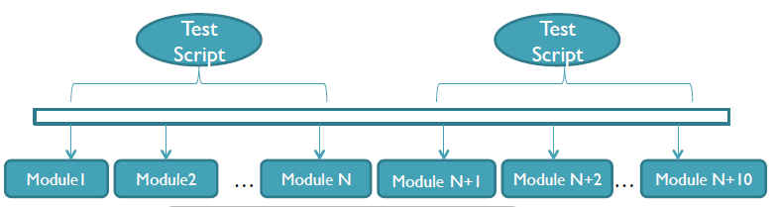

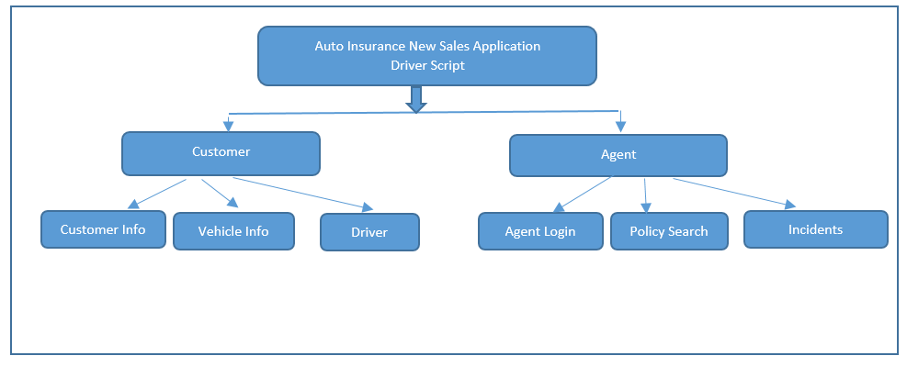

Advantages:   
1. Require little automation expertise   
2. Rapid development of automated tests.   
3. Modular division of scripts leads to easier maintenance and Lower maintenance time.   
  
Challenges:   
1. Requires careful planning   
2. Modular Framework have test data embedded in it. So when test data needs to be updated we need to change the code of script. This is major challenge when we deal with multiple test scripts.   
  
**Data Driven framework**

Data driven framework is where the test input and expected output results are stored in a separate data file so that single driver script can execute all the test cases with multiple sets of data.   
It is organized to correspond with the modular code design and it drives the direction of the script.

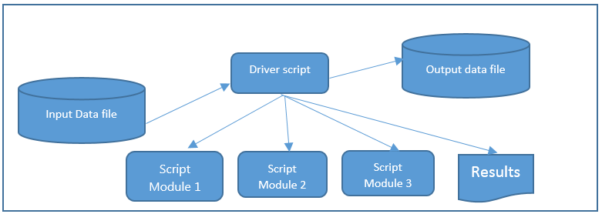

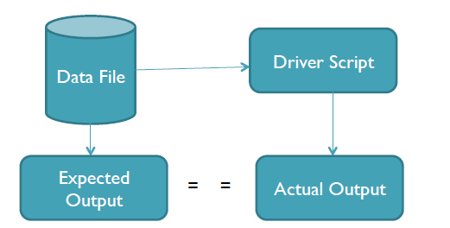

**Advantages:**

1. This framework reduces the number of overall test scripts and code required to implement   
 all the test cases.

2. Offers greater flexibility when it comes to maintenance and fixing of bugs.

3. The test data can be created before test implementation is ready or even before the system to be   
 tested is ready.

**Disadvantages:**

1. Test data and Test scripts are closely related which means that if Test data changes Test scripts needs to be changed and vice versa.
2. We have to again do coding for small changes in Test requirements. To resolve this types of issue Keyword driven framework is introduced.

**Keyword Driven Framework**

Keyword Driven Framework is an application independent framework utilizing data tables and self-explanatory keywords to explain the actions to be performed on the application under test.

* Separates programming work from actual test scripts
* Scripts are represented as a set of keywords to form test scripts
* Requires development of individual data tables and keywords
* The functionality of AUT is documented in a table.

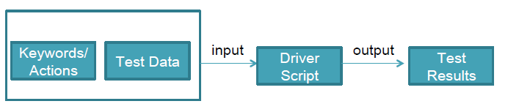

Input Data file

Output Data file

Driver script



Keyword Func3

Keyword Func2

Keyword Func1

Results

Auto Insurance New Sales Application  
Driver Script

Customer Info

Customer

Incidents

Policy Search

Agent Login

Vehicle Info

Driver

Agent

HH

Advantages:

* Keyword driven testing framework will have all the advantages that data driven testing has.
* Automation expertise is no required to maintain or create a new set of test cases.
* Keywords are reused across multiple test cases.

Disadvantages:

* Keyword driven framework is more complicated framework than data driven .

Hybrid Framework

